Project Testing
Screenshots
Date | 12 July 2026
Team ID | SWTID-2026-4644
Project Name | Smart Lender
Phase | 6. Project Testing

Provenance
All four screenshots below are genuine captures of the live, running Smart-Lender application — not mockups, stock images, or AI-generated illustrations. Each was produced by starting the real Flask server (python app.py) and either rendering a GET route or POSTing real form data to /submit, then capturing the resulting page with wkhtmltoimage.
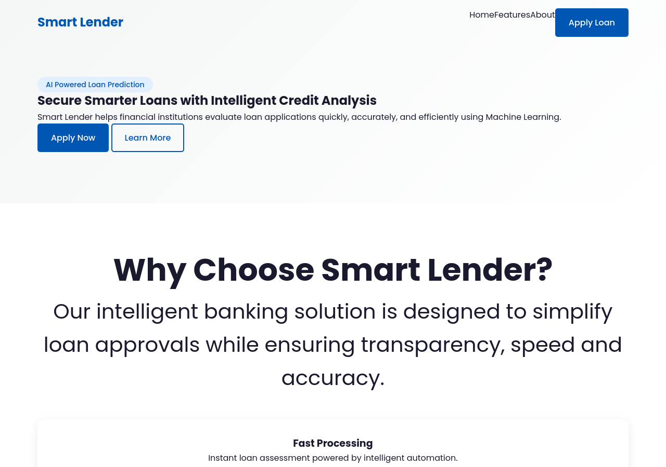
Figure 1: Home page (home.html) — GET / captured live.
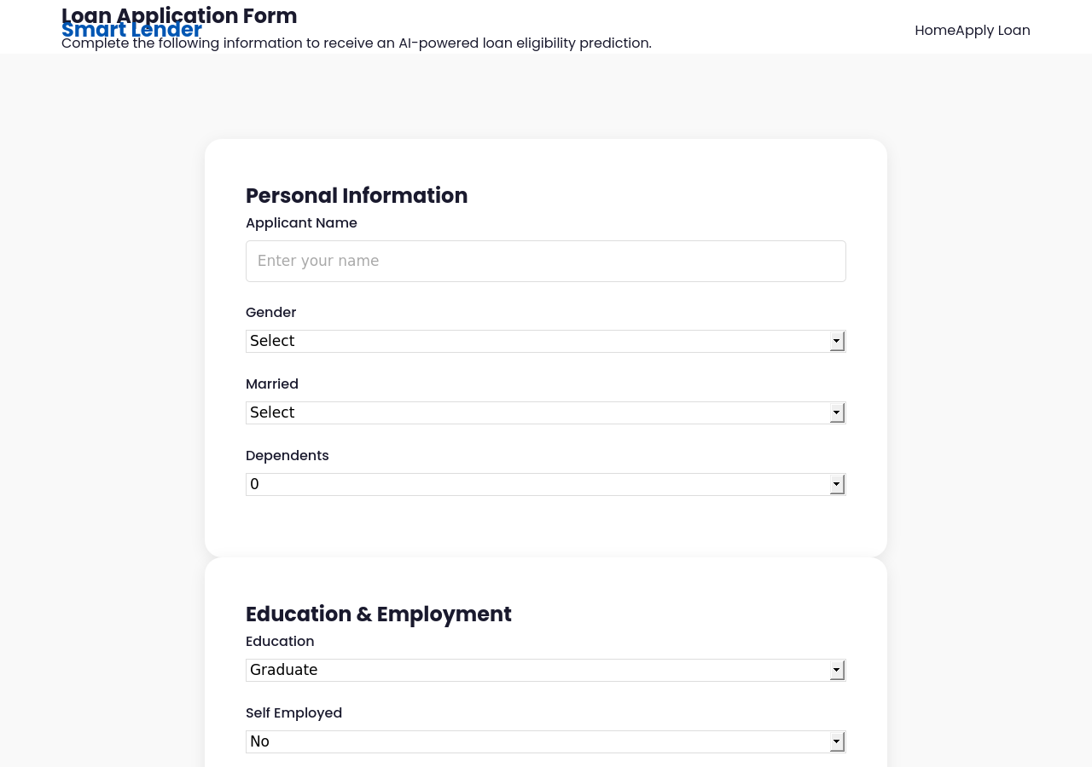
Figure 2: Loan application form (predict.html) — GET /predict captured live, showing all 11 input fields.
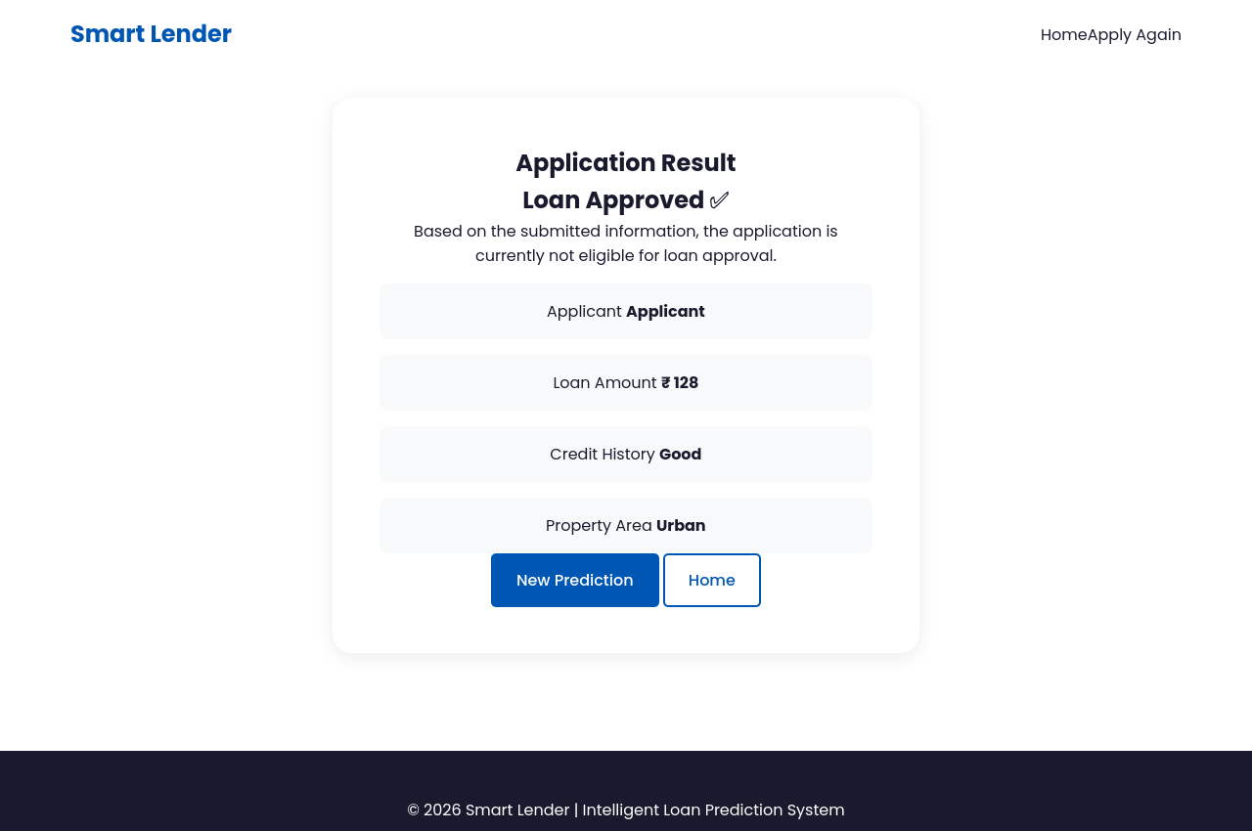
Figure 3: Result page for the low-risk applicant profile (Scenario 1) — actual live model output: “Loan Approved”.
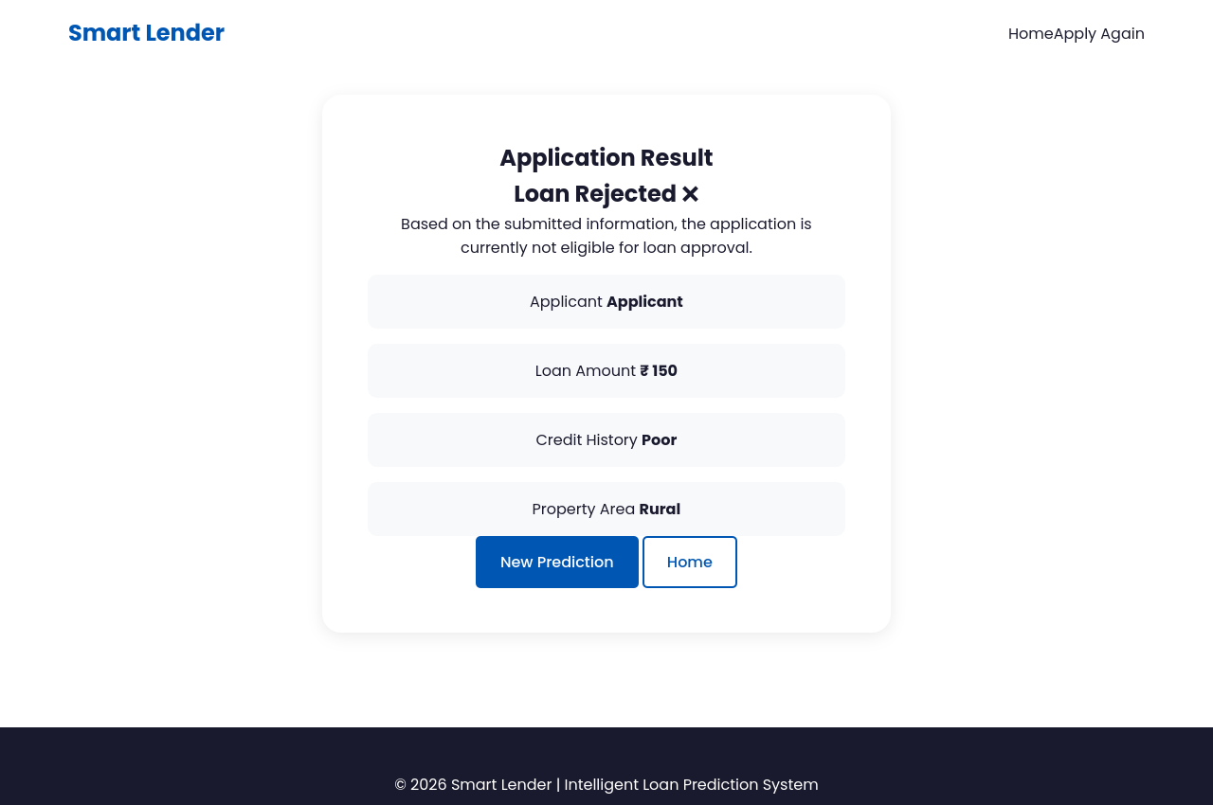
Figure 4: Result page for the high-risk applicant profile (Scenario 2) — actual live model output: “Loan Rejected”.

Capture Method Detail
The exact request payloads used to produce Figures 3 and 4 are logged in Functional_Testing.docx (test cases FT-03, FT-04) and Test_Cases.docx (TC-03, TC-04) for full reproducibility.

